TPC4

1.

a)

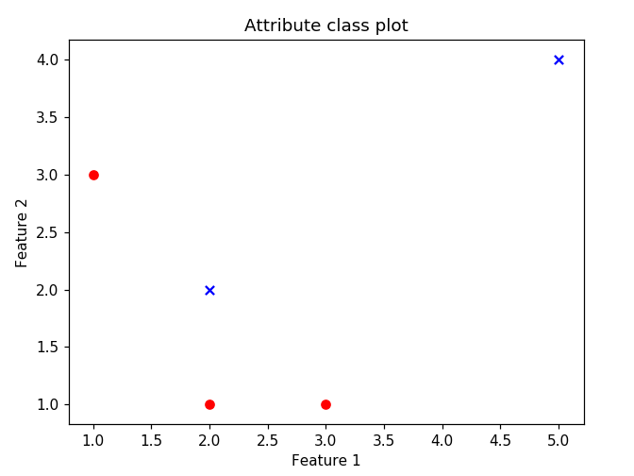

Given that the red circules are a=0 and blue crosses a=1, we can verify that this data is not linearly separable, because is not possible to “draw” a line that separate the data by feature.

1. Using the following gradient formula as role model:

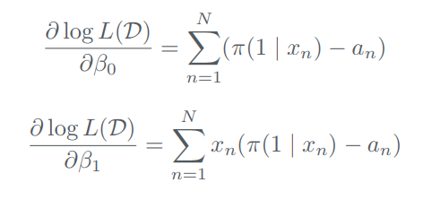

For the first weight beta0 = 0, we calculate the first gradient wich gave a value of 0.5 and its corresponding new weight (using gradient descent): -0.5. We used the top formula from above, because this weight doens’t depends on any atribute.

For the second and third weight, beta1=0, beta2=0, we also calculate the gradient wich gives value of -0.5 each and its corresponding new weights (using gradient descent) 0.5 each. We used the bottom formula from above, because this weights depends on its attributes.

Giving the following recalculated weights:

Beta0=-0.5

Beta1=0.5

Beta2=0.5

c)

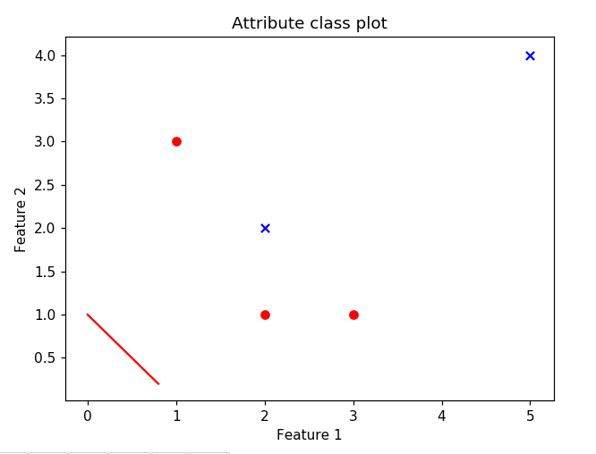

We can verify, that it does not properly classify tha data.

Grupo nº 37

João Silvestre, nº 80996

João Pestana, nº 79515